Epta UK Ltd
Highfield Works Highfield Road,
Bradford, BD10 8RU
Tel. +44 1274 703203
Fax +44 1274 616346
www.epta-uk.com
EPTA S.p.A.
Via Mecenate, 86 - 20138 Milano - Italy
T. +39-02 55 403 211
F. +39-02 55 401 023
info@eptarefrigeration.com
www.eptarefrigeration.com
Registered Number: 00726533
Modern slavery statement for financial year ending 2025
This statement is made pursuant to s.54 of the Modern Slavery Act 2015 and sets
out the steps that Epta UK has taken and is continuing to take to ensure that modern
slavery or human trafficking is not taking place within our business or supply chain.
Modern slavery encompasses slavery, servitude, human trafficking and forced
labour. Epta UK has a zero-tolerance approach to any form of modern slavery. We
are committed to acting ethically and with integrity and transparency in all business
dealings and to putting effective systems and controls in place to safeguard against
any form of modern slavery taking place within the business or our supply chain.
Our business structure
As part of the multi-national Epta group, Epta UK are renowned throughout the UK
for our wide knowledge and experience applied to the design, production, service
and maintenance of commercial refrigeration systems.
Our high-risk areas
Our ‘high risk areas’ are within the supply chain and service functions.
One direct supplier high risk area involves our use of temporary agency workers in
our Bradford factory, where some migrant workers could be contracted via
employment agencies.
We carry out due diligence checks to ensure that our suppliers meet and maintain
the standards that we expect. To that end we only use appropriately accredited
suppliers, with membership of TEAM, Recruitment & Employment Confederation,
British Institute of Recruiters and Association of Labour Providers. We also have
documented audit procedures for these suppliers and conduct senior manager visits.
As part of the due diligence, we would also initiate an online search to ensure that a
particular organisation has never been convicted of offences relating to modern
slavery and specific on-site audits for high-risk suppliers which includes a review of
working conditions. Our anti-slavery policy forms part of our contract with all
suppliers and they are required to confirm that no part of their business operations
contradicts this policy. The above steps are also taken when selecting the use of a
sub-contractor.
As with previous years, we engaged a comparatively low number of temporary agency workers in the Bradford factory compared with our pre-Brexit workforce.
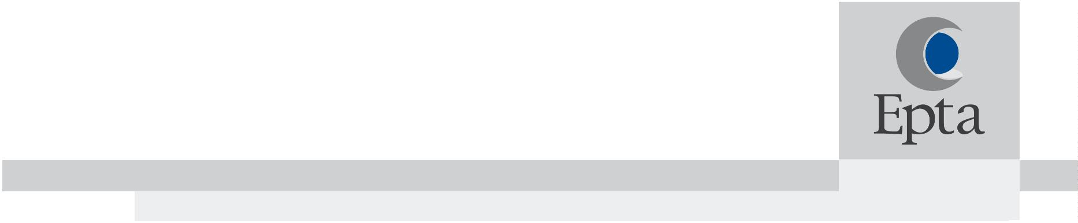

2
We have trained all our employees, including those in the factory, on our corporate
Code of Ethics. A key part of this document is respect of every person’s human
rights whether they are directly employed or associated with Epta.
The Code of Ethics references a zero tolerance towards forced labour, trafficking and
enslavement. The training also highlights warning signs of modern slavery; namely
lack of language skills, being dropped at work by a third party, ill health or low mood.
We continue to take steps to understand in more detail the other areas of our supply
chains where there may be a risk.
Our suppliers
We have introduced a code of conduct document that forms a key part of our Supply
Chain and Procurement strategy and is a fundamental part of our supplier selection
and on-going evaluation processes.
Epta UK operates a supplier policy and requires suppliers to agree to our Code of
Conduct. We conduct due diligence on all suppliers before allowing them to become
a preferred supplier.
Our supplier questionnaire constantly evolves, to reflect the regulatory and non-regulatory requirements we have to adhere to.
In addition to the above, as part of our contract with suppliers, we require that they
confirm to us that:
1
2
3
. They have taken steps to eradicate modern slavery within their business
. They hold their own suppliers to account over modern slavery
. (For UK based suppliers) They pay their employees the National Living Wage as a
minimum
4
. (For international suppliers) They pay their employees any prevailing minimum wage
applicable within their country of operations
5
. We may terminate the contract at any time should any instances of modern slavery
come to light
Our policies
We operate a number of internal policies to ensure that we are conducting business
in an ethical and transparent manner.
These include:
1
. Modern Slavery Policy. This policy sets out the Company’s stance on modern slavery
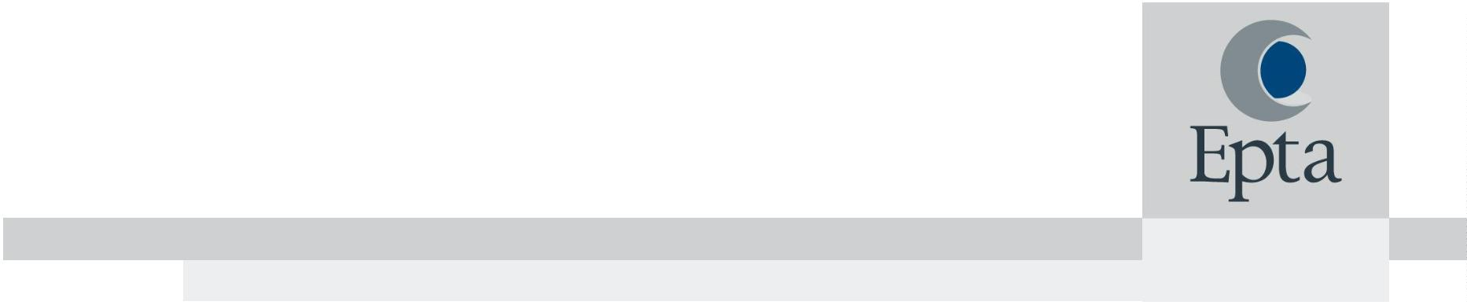

3
and explains how employees can identify any instances of this and where they can
go for help.
2

. Recruitment Policy. We operate a robust recruitment policy, including conducting
eligibility to work in the UK checks for all employees to safeguard against human
trafficking or individuals being forced to work against their will.
3. Whistleblowing Policy. We operate a whistleblowing policy so that all employees
know that they can raise concerns about how colleagues are being treated, or
practices within our business or supply chain, without fear of reprisal. There is also
an Epta group Whistleblowing policy, which is accessible to all and is an anonymous
and confidential route to raise issues independently of UK management.
4
. Equality, Diversity & Human Rights Policy. This policy details how we support the UN
guiding principles and accept corporate responsibility to respect human rights.
Training
We are constantly reviewing our training for our procurement / buying / HR teams and other relevant employees, so that they understand the signs of modern slavery and what to do if they suspect that it is taking place within our supply chain.

We have trained all our employees, including those in the factory, on our corporate
Code of Ethics. A key part of this document is respecting every person’s human
rights whether they are directly employed or associated with Epta.
The Code of Ethics references a zero tolerance towards forced labour, trafficking and
enslavement. The training also highlights warning signs of Modern Slavery: namely
lack of language skills, being dropped at work by a third party, ill health or low mood,
Our performance indicators
The outcome of third-party assessment.

SMETA - (Sedex Members Ethical Trade audit) is a widely recognized global social
compliance scheme.
Based on the Ethical Trade Initiative, SMETA methodology incorporates working
conditions in terms of labour, health and safety, environment and business ethics as
well as the supply chain.
Ecovadis - evaluates corporate social responsibility (CSR) across four major themes: Environment, Labour & Human rights, Ethics and Sustainable procurement, where companies are assessed on their policies, actions and results to prevent forced labour, human trafficking, and child labour in businesses’ operations and supply chains.

4

In addition, we will know the effectiveness of the steps that we are taking to ensure that slavery and/or human trafficking is not taking place within our business or supply chain, if:
- No reports are received from employees, the public, or law enforcement agencies to indicate that modern slavery practices have been identified.
Approval for this statement
This statement was approved by the Epta UK General Manager in July 2026.

David Wormald
HR Director – Epta UK

